Solar Eclipse Health & Safety |  |  | 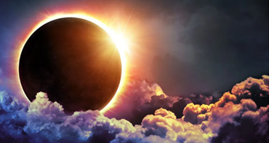
PROTECT YOURSELVES & THOSE WE SUPPORT DURING THE UPCOMING SOLAR ECLIPSE
What is a solar eclipse?
A solar eclipse occurs when the moon moves between the sun and the earth. The moon blocks the sun preventing the sunlight from reaching the earth.
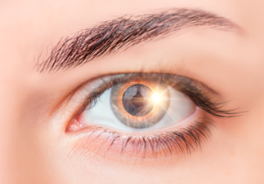 | Protect Your Eyes!  It is never safe to look directly at the sun, especially during a solar eclipse! Looking directly at the sun can cause severe and permanent damage to your eyes by harming or destroying the cells in your retina (i.e., the back of the eye). This damage can be temporary or permanent and can occur with no pain. It can take a few hours to a few days after viewing the solar eclipse to realize if damage has occurred.
If a person you are supporting at Aspire of WNY looks at the sun during the eclipse without proper eyewear, call the
ON CALL NURSE for support at 716.559.1845

Symptoms to watch out for are eye soreness or pain, light sensitivity, temporary eye floaters or flashers, blind spots, or other vision changes.

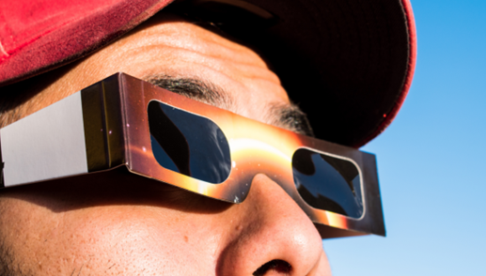 |  | Use only approved eclipse glasses or another approved method (https://www.exploratorium.edu/eclipse/how-to-view-eclipse) to view the solar eclipse safely and without damaging your eyes.  - Do NOT use your smartphone camera.  - Do NOT use a traditional camera viewfinder.  - Do NOT use unsafe filters.
Protect Your Skin!  Even during a partial solar eclipse or during the partial phases of a total eclipse, the sun will still be very bright. If you are watching an entire eclipse, you may be in direct sunlight for a long time. Wear sunscreen, a hat, and protective clothing to prevent skin damage. |  |  |  | 